Lecture 7

Homework #7 (due March 20, 2019)

Data types:

Primitive (“atoms”)

Collections (“molecules”)

Strings, lists, tuples, sets, dictionaries

Membership, iteration, slicing

Lists are mutable

Tuples are immutable (but you can “mutate” mutable elements within a tuple

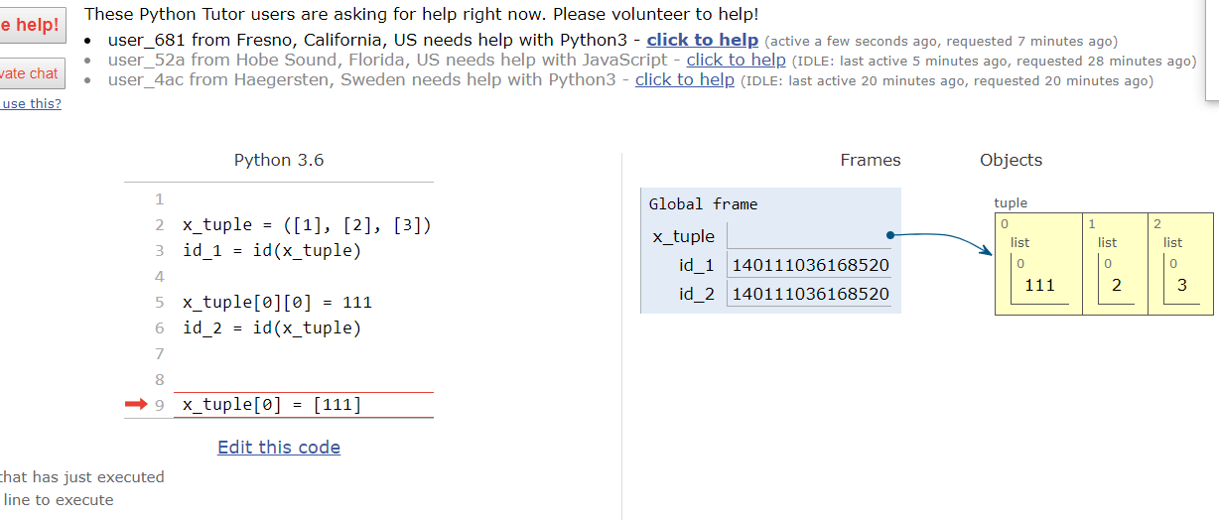

Sets - mutable, immutable

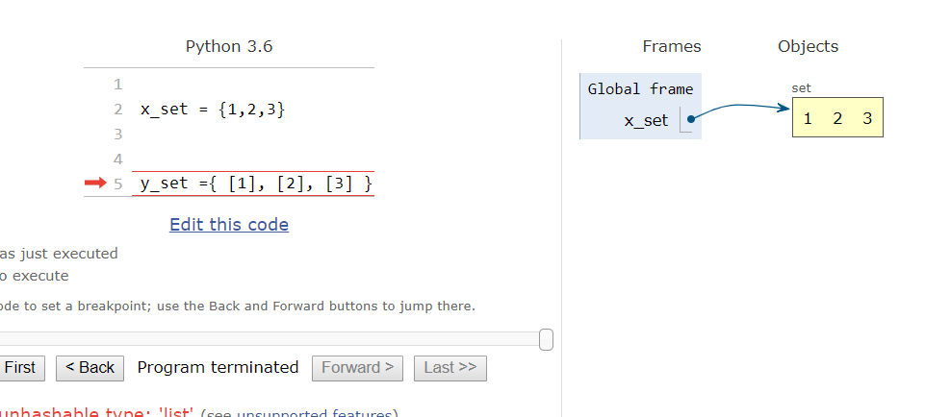

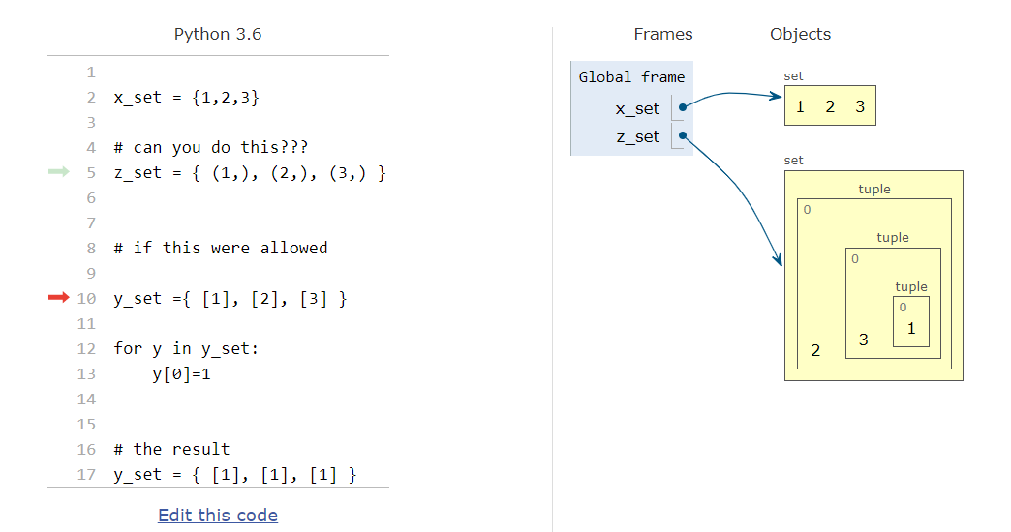

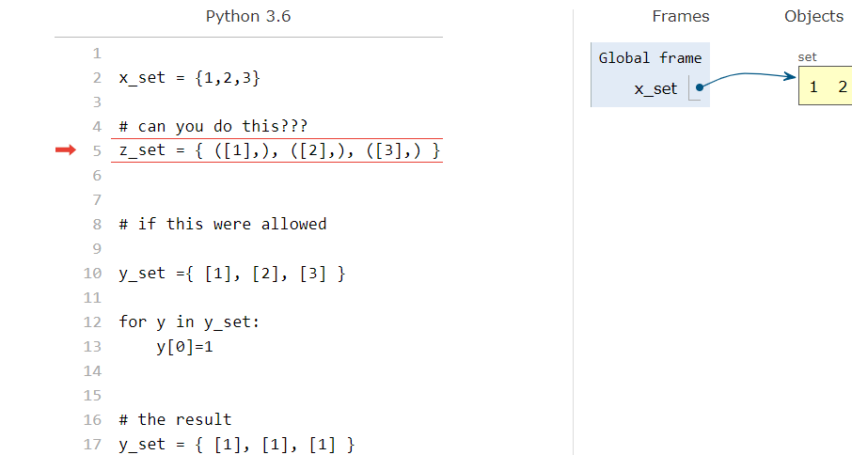

Dictionary

(keys, values):

Vi editor

In the next 2 assignments, you will consider 3 implementations for the editor

1. A file is a sequence of bytes

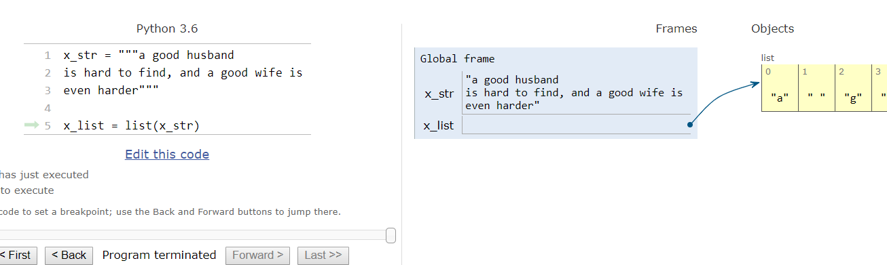

1. A file is a list of lines

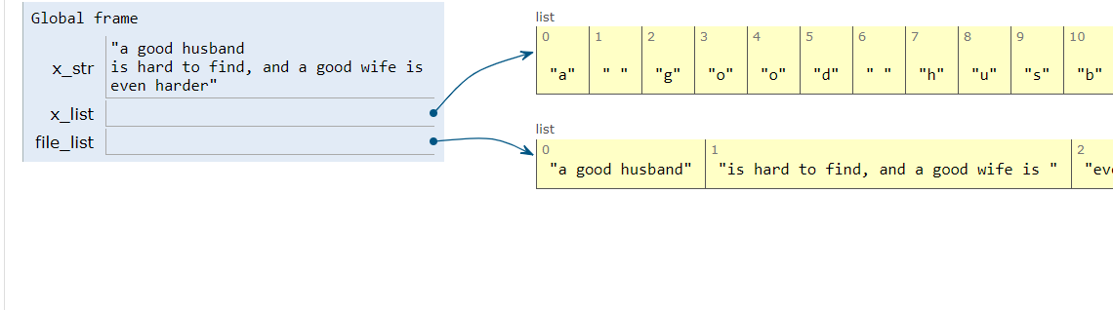

1. A file is a linked list

String representation:

X_str : data itself

Cursor: displacement from the start of the string

We will show the results of our commands to calling my_print()

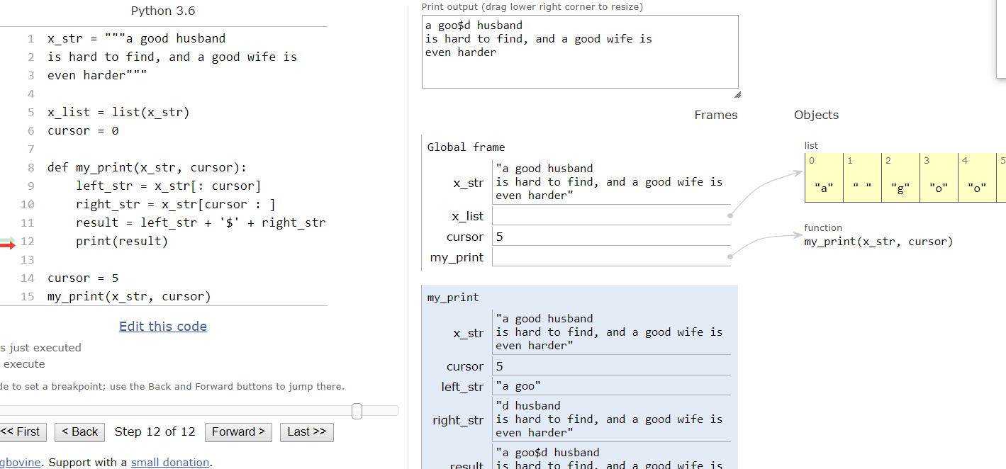

Some examples:

1 goto start of file

2 goto end file

def start_file_cmd():

return(0)

def end_file_cmd(x_str):

return(len(x_str))

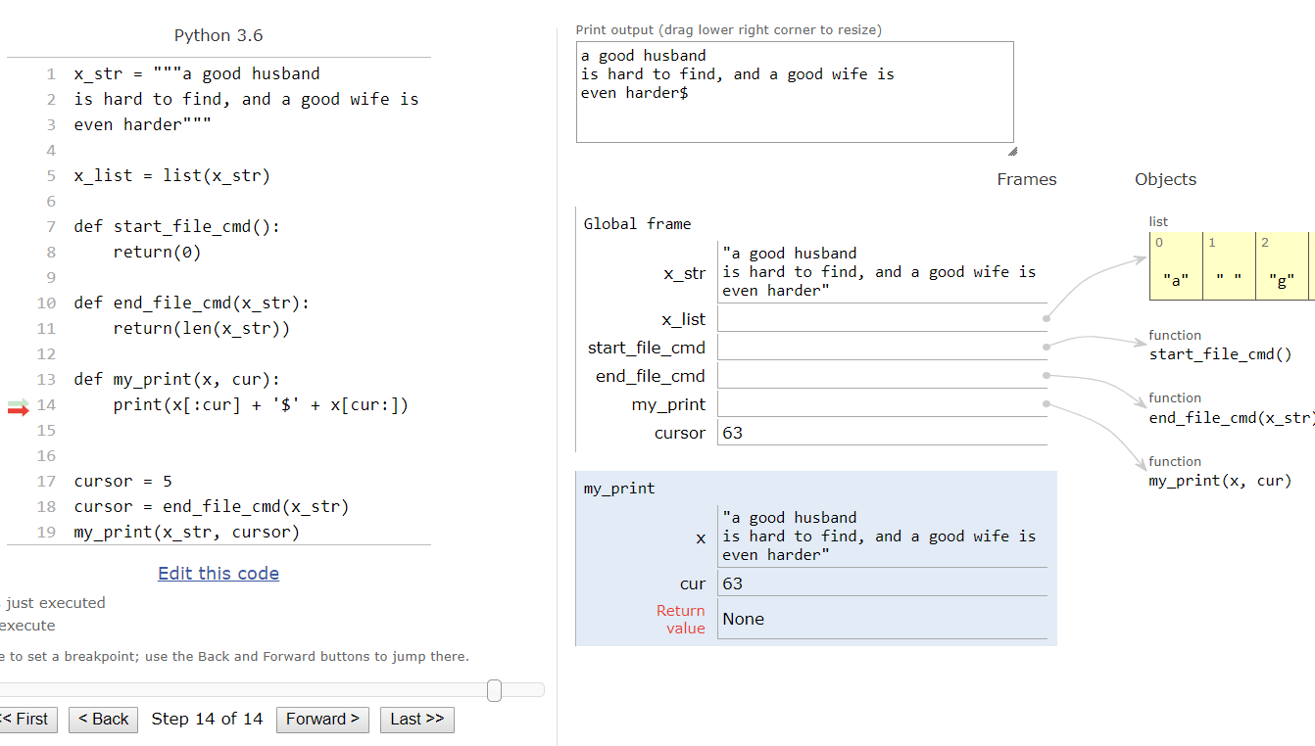

Find a substring

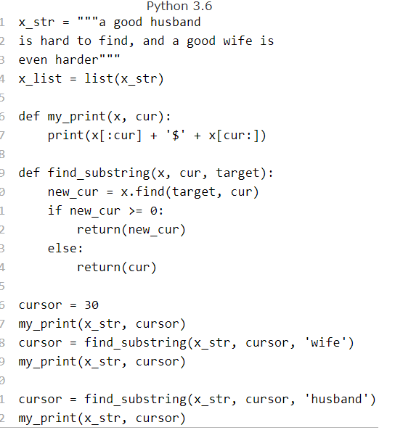

Reverse find:

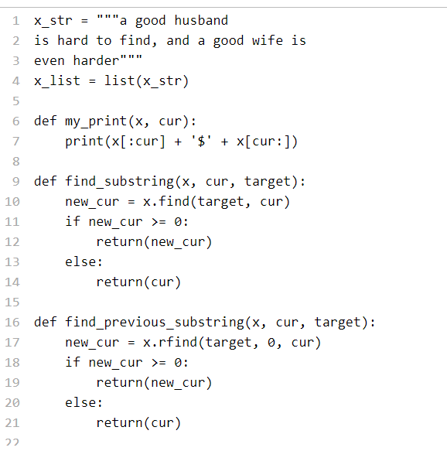

Move to the right and to the left by one position

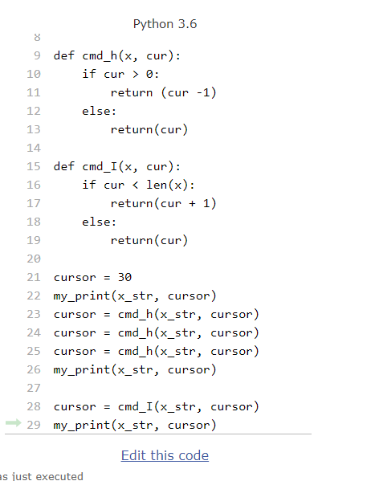

Delete at the current position

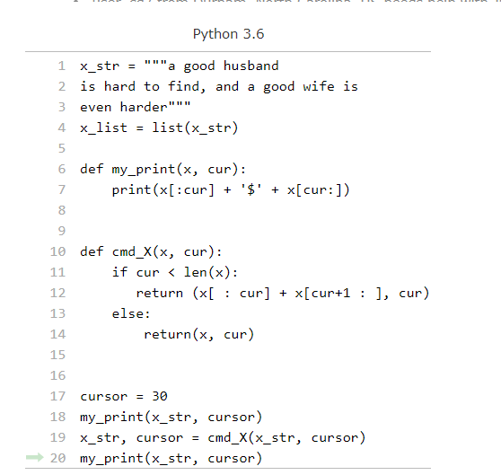

Second part: your file is a list of lines

